**Program no____1_____**

**Program Title________LED on/off_________**

**Aim Demonstrate to show ON/OFF of a LED Using Pushbutton(Digital**

**Output).**

**Hardware Required**

* Arduino Board
* LED

**Circuit Diagram**

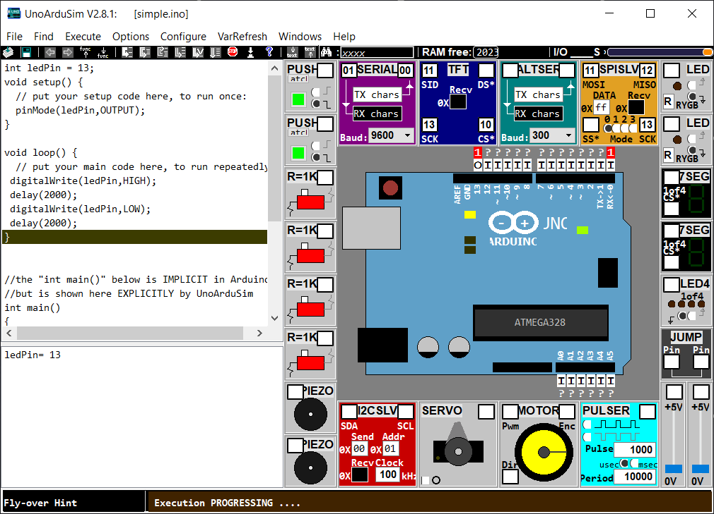

**Code:**

|  |  |
| --- | --- |
| void setup() |  |
|  | { |
|  | pinMode(13, OUTPUT); |
|  | } |
|  |  |
|  | void loop() |
|  | { |
|  | digitalWrite(13, HIGH); |
|  | delay(300); // Wait for 1000 millisecond(s) |
|  | digitalWrite(13, LOW); |
|  | delay(300); // Wait for 1000 millisecond(s) |
|  | } |

**Observation /Output**

**LED will Blink.**